 | Year 11 Methods  Week 3 Quiz | $$\frac{}{15}$$

Name: __________________
1. | True or False: A relation is a function. | 1
2. | Which of the following is NOT a function?  A y = B x = y 2 − 7y + 1 C x2 − y + 1 = 0 D 3x − y − 1 = 0 | 1
3. | Which graph represents a function?  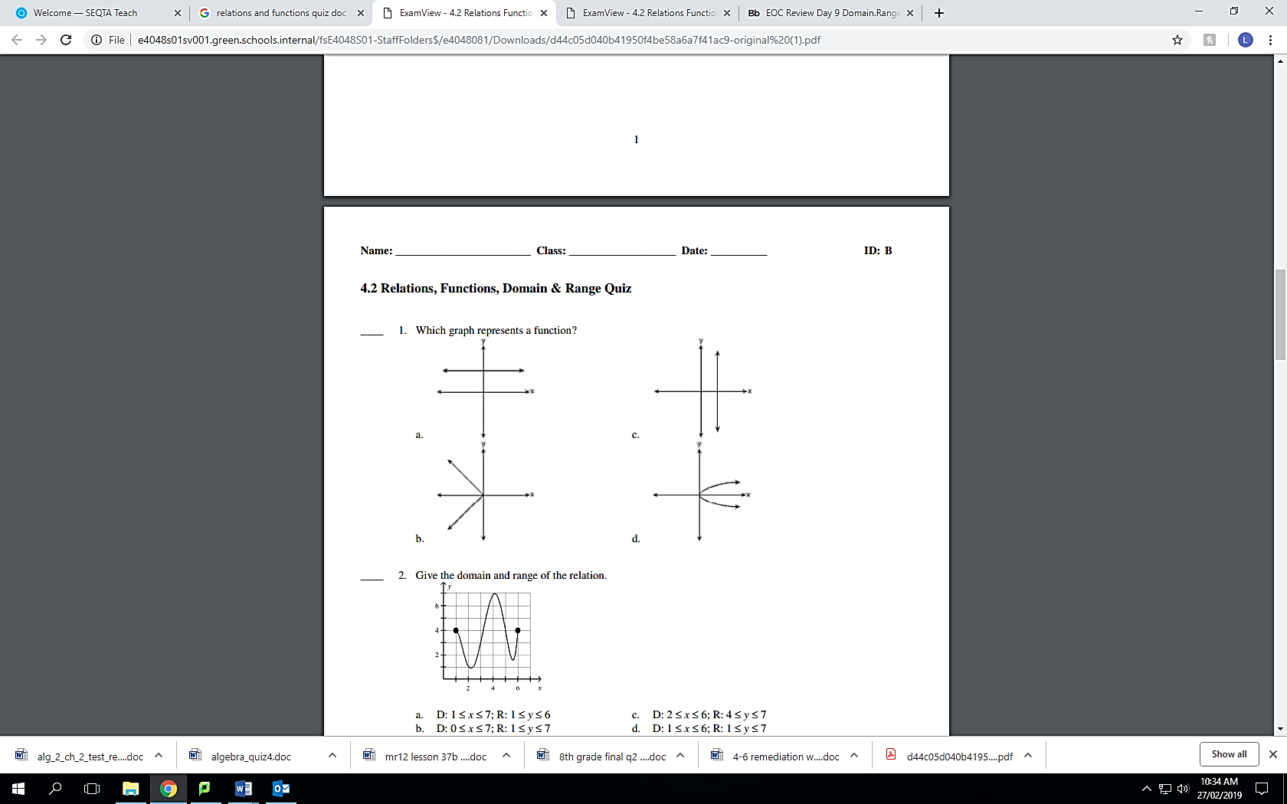 | 1
4. | What is the domain of the function graphed below?  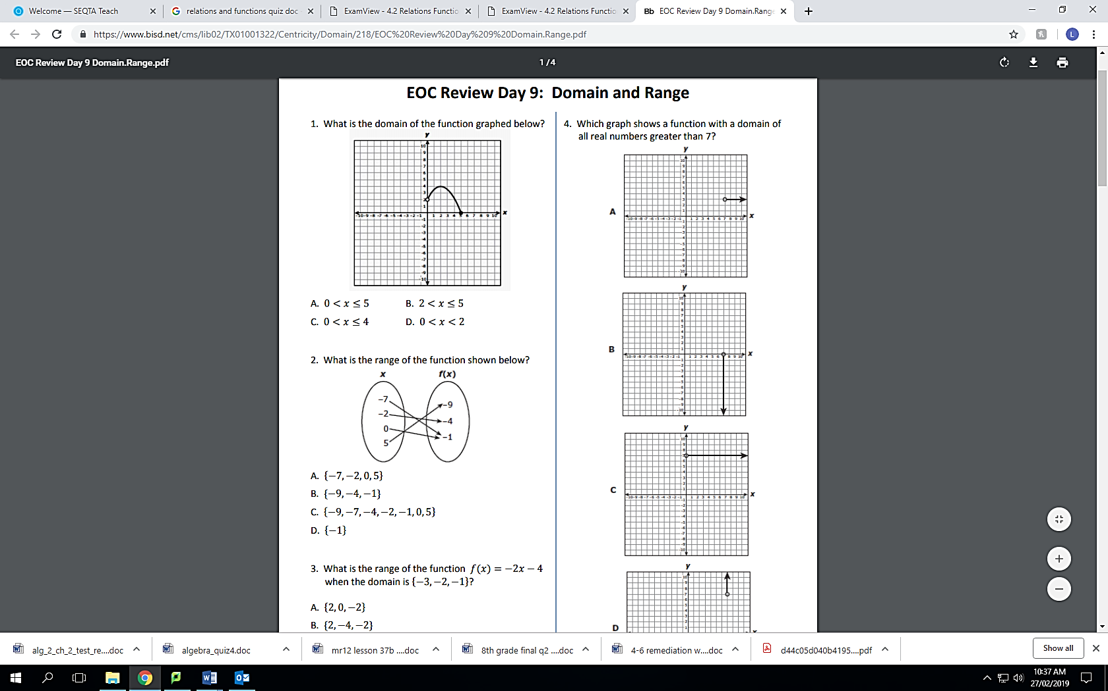 | 1
5. | What is the range for the mapping below? | 4
6. | What is the range of the function f(x) = 5x + 4 when the domain is {-2, 3, 5} | 2
7. | If , then find:  - $f(-3)$  - $f\left(x\right)=-2$ | 3
8. | The function f(x) = {(1, 2), (2, 4), (3, 6), (4, 8)} can be represented in several other ways. Which is NOT a correct representation of the function f(x)?  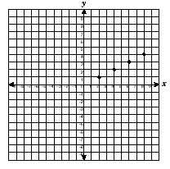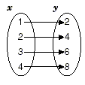  - b) c) x is a natural number less than 5 & y is twice x  d) y = 2x and the domain is {1, 2, 3, 4} | 1
9. | Find the degree measure of the arc of a sector with area 36π if the area of the circle is 144π. | 3

